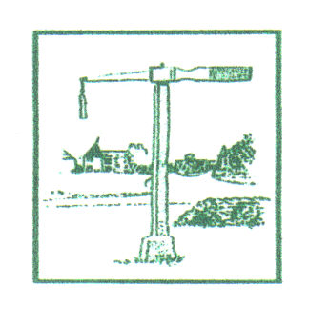

Offham Parish Council

Community Awards Scheme 2023

Do you know somebody in Offham who deserves to be acknowledged and recognised for making a significant contribution over a considerable period of time to our local community?

The Parish Council is participating in the Kent Association of Local Councils Community Awards Scheme 2023 and is also running its own Parish Council Awards Scheme.

All nominations must be received by Monday 6th February 2023. For more details please see www.offham-pc.gov.uk.

