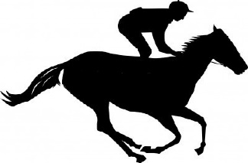
This Photo by Unknown Author is licensed under CC BY-NC
This Photo by Unknown Author is licensed under CC BY-NC
This Photo by Unknown Author is licensed under CC BY-NC
Offham Parish Council
Race Night
Saturday 27th April
7.30pm
At Offham Village Hall

£15 to include a light supper
Bring your own drink and glasses
For tickets please call Sue Williams
07732 267121
All profits will go towards village projects.

This Photo by Unknown Author is licensed under CC BY-NC
This Photo by Unknown Author is licensed under CC BY-NC
This Photo by Unknown Author is licensed under CC BY-NC
Run by The Malling Lions

